For students

Examples of the states of water in nature

Where can you see the different states of water in nature? Take photos of water in different states in your local environment and place them in the table below.

State of water | Example | Your example | Other examples
SOLID | Ice  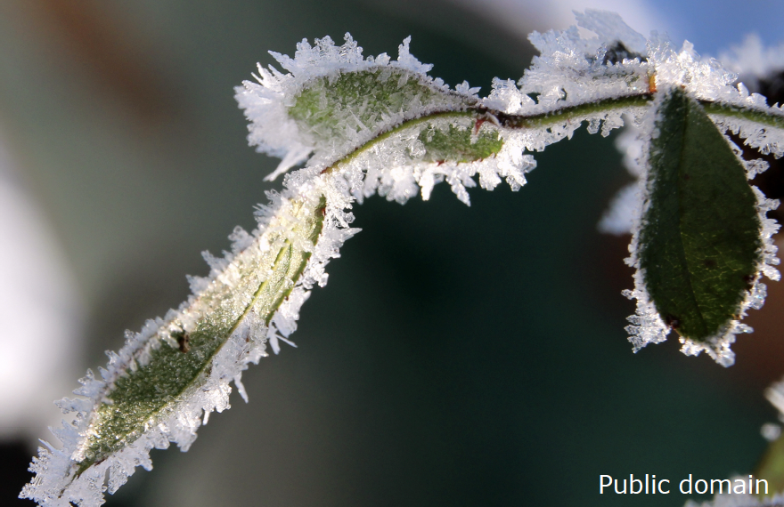 |  | Hail, snow, glacier, sleet, sometimes clouds can have solid water in them too.
LIQUID | River  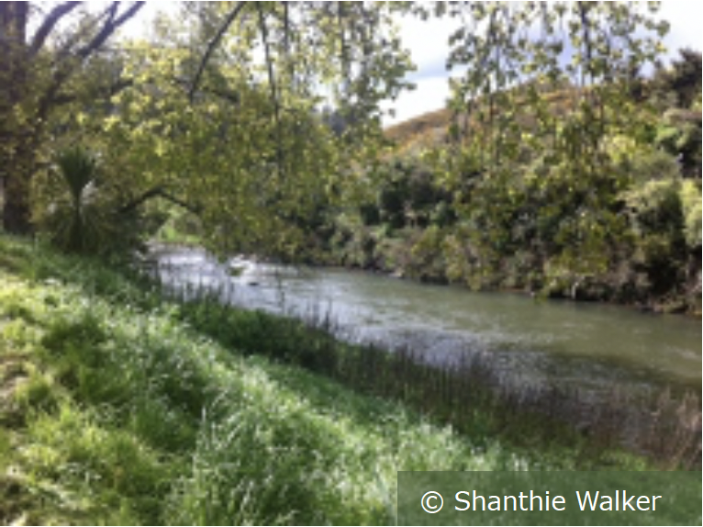 |  | Rain, puddles, streams, springs, ponds, wetlands, lakes, clouds, ocean, tap water.
GAS | Water vapour/steam  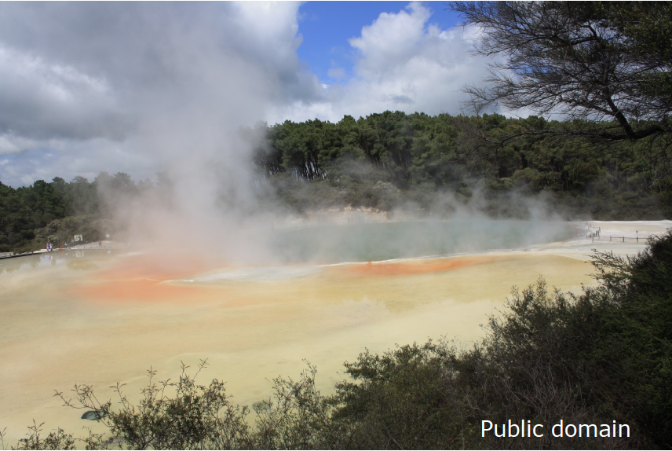 |  | Water vapour, steam, clouds.

