Water for a day challenge

Choose a water challenge to complete for one day from the list below.

Water for a day challenges:
- should not include drinking water – drink as much water as you need without counting it in your challenge
- must include good personal hygiene – keeping your hands and body clean and flushing toilets for health and wellbeing.

Terrific water challenge

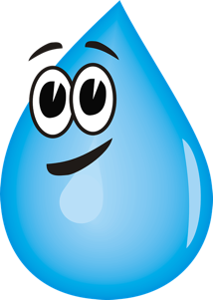
Challenge level: Medium

Water you can use for one day: 100 litres per day

(10 buckets full)

Challenge yourself to save some water from your regular daily use. You’ll need to think about which water uses you could do without.

Tips: Don’t be wasteful with water, have a short shower, flush the toilet only when necessary.

Super water challenge

Challenge level: Difficult

Amount you can use in one day: 80 litres per day (8 buckets full)

Take a bigger challenge by reducing your water use in half! You’ll need to think carefully about what you will use water for throughout the day. People in most western countries use more than 80 litres per day, so it might require going without a few things, just for the day. Think carefully about how you might wash yourself and keep clean.

Tips: Have a short shower, use hand sanitiser, avoid water wastage, flush the toilet only when necessary.

Mega water challenge

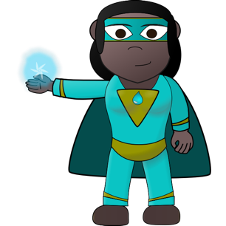
Challenge level: Very difficult

Amount per day: 50 litres per day

(5 buckets full)

Are you up for a big challenge? Use your water saving superpowers to conserve water by the litre!

This may require going without some water uses, just for the day. You’ll need to plan your water use and be strict with the amounts you use for each task you need it for. This amount of water is used by people who don’t have easy access to a water source.

Think carefully about how you might wash yourself and keep clean.

Tips: Have a very short shower, use hand sanitiser, avoid water wastage, reuse your water if possible, have low water use meals, flush the toilet only when really necessary.

