ACTIVITY: Water issues and effects

Inquiry stage | Curriculum links  Levels 3-4
4. Find your flow | Science:  Nature of Science: Investigating in Science  Social sciences: Social studies

Activity idea

In this activity, students explore the Waikato region’s water issues: their causes, effects and alternative possibilities.

By the end of this activity, students should be able to:
- identify issues for our freshwater sources and water bodies
- identify the effects, alternative solutions and future consequences of current issues.
For teachers

Introduction/background

As the population of Waikato increases and water supplies are challenged with human impacts and climate change, a plentiful supply of drinking water in the future is not guaranteed. We need to protect and look after our drinking water to make sure that we have enough water to go around now and in the future.

Water issues in Waikato

The Waikato River is one of the most heavily used rivers in New Zealand.

Water from the Waikato River starts off very clear and blue, but by the time it reaches Hamilton, it is brown, cloudy and dirty looking. This is due to a variety of factors, including large amounts of bacteria, sediment and nutrients (such as phosphorus and nitrate). Learn more about water quality factors that affect the Waikato River in this article and interactive.

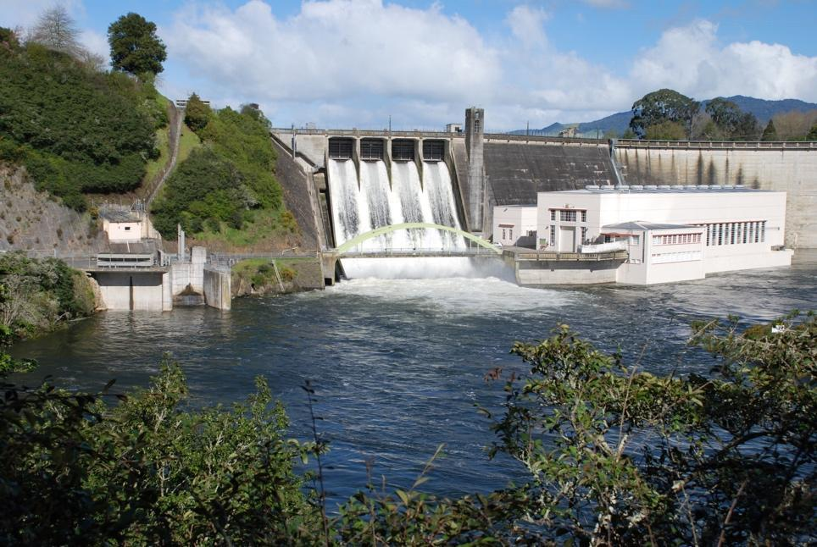
Even prior to human settlement, the water arriving at Port Waikato would not have been clear and completely free of microbes. The Waipā River contains a lot of sediment because of its geology, which is a natural phenomenon, leaving the lower reaches of the river muddy and brown.

However, levels of nitrogen and phosphorus are increasing about 1–2% per year. Bacteria levels are also high. The way we are managing the river today could have negative consequences for future generations of the region.

Thinking about the Waikato River’s issues and impacts

The first section of the river from Lake Taupō to Hamilton includes hydro lakes, native bush, some settlements and farmed areas. The lower section goes through the Waipā district and is more intensively farmed, with many other influences. Hamilton City also sits alongside the river.

Due to changes in flow caused by dams, lakes, power schemes and other water use, water flows from Taupō to Orakei Korako in 5 weeks instead of the original 2–3 days. This encourages algal growth and makes the water more green. Read about changes to rivers as they move through catchments in this article.

Human impacts are significant for the Waikato River and are typically increasing with time. There is a strong need for more work and planning to improve the water quality of the river and restore its health. Many organisations are working in this space and making progress, but we all have an impact and will need to play a part in the restoration.

The following websites have more detailed information about the Waikato River’s health and water quality:
- Waikato Regional Council: How clean is the Waikato River?
- Waikato Regional Council: Downstream changes to water quality

Alternative possibilities

This activity encourages future problem solving, creative thinking, problem solving, critical thinking and deep learning. Students examine issues that are relevant to their local water bodies and explore the causes, effects, solutions and their possibilities, gaining insight and a better understanding of how to solve these issues.

Alternative possibilities could include reducing our water use, renewable energy solutions, climate-friendly travel options, waste minimisation, reducing food waste, composting, soil regeneration, planting, electricity efficient use, eating less meat, public education and more!

What you need

- Student handout Kaitiakitanga
- Student handout Freshwater ecosystem health
- Student handout Thinking about causes and effects of issues
- Smart Water: Inquiry plan and student reflection – slideshow

Principles of kaitiakitanga

- Use the articles Kaitiakitanga and mana whakahaere and Understanding kaitiakitanga to learn more about kaitiakitanga.

- Discuss the importance of kaitiakitanga for the future of waterways.

- Use student handout Kaitiakitanga to draw an illustration or digital representation of what kaitiakitanga means to students.

Thinking about human impacts on local waterways

- Explore the interactive Our use of water – impacts on water quality to learn more about how our use of water can affect water quality. Brainstorm water issues or human impacts that are relevant for your local awa.

- View the student handout Freshwater ecosystem health. Encourage students to choose an issue from the infographic to unpack. Encourage discussion about the causes and effects of the issues and the impact they have on water quality, te mana o te wai and biodiversity.

- Complete the student handout Thinking about causes and effects of issues. The current way of doing things is not the only way. Are there alternative possibilities that incorporate kaitiakitanga principles to meet the needs of the community?

- Examples of possible answers are given in the student handout Thinking about causes and effects of issues – example answers. Unpack these with students and consider the future consequences of the alternative possibilities given in the right-hand column of the table.

Student reflection on inquiry

- Smart Water: Inquiry plan and student reflection – slideshow slides 9–14 provide a space for students to reflect on their findings, summarise main points, find issues of concern and decide on next steps for learning. This information is useful for considering next steps and action in the activity Being smart with water.

Extension ideas

Use these Science Learning Hub resources to build on learning about freshwater issues:
- Land use – impacts on waterways – article
- Water issues activity – student activity with a global focus
- Water pollutants on trial activity – student activity

This activity is part of a suite of resources that support Smart Water – a context for learning, which provides students and teachers with opportunities to connect with water and learn more about drinking water in the Waikato region. The science and mātauranga concepts that underpin Smart Water are transferable to other locations in Aotearoa New Zealand. Smart Water is a partnership between Hamilton City Council, Waipā District Council and Waitomo District Council. It aims to foster a greater understanding and appreciation of water from source to tap and supports schools, organisations and communities to use water sustainably.

For students

Kaitiakitanga

Use the articles Kaitiakitanga and mana whakahaere and Understanding kaitiakitanga to learn more about kaitiakitanga.

Consider what kaitiakitanga means to you. Draw an illustration or digital representation of your ideas. An example is provided below.

Kaitiakitanga having a duty of care, guardianship, protection

Caring for natural resources and taonga

Leaving our taonga in excellent health for next generation (intergenerational equity)

Connecting with water and acting for its welfare

You will find the full activity and teacher support here.

Freshwater ecosystem health

This poster is from the Ministry for the Environment & Stats NZ (2020) New Zealand’s Environmental Reporting Series: Our freshwater 2020.

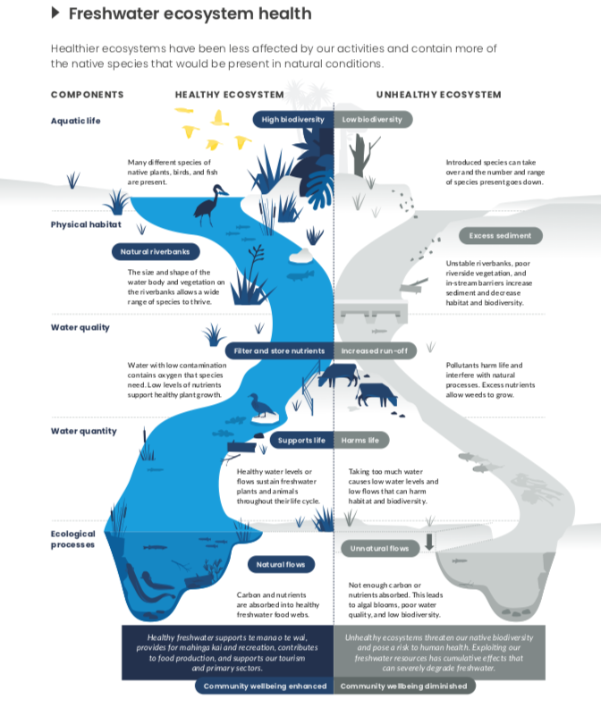
Thinking about causes and effects of issues

Example issues or human impacts | Causes and why we have this issue | Effects of this issue | Alternative possibilities  and kaitiakitanga | Future consequences of alternatives

Thinking about causes and effects of issues – example answers

Example issues or human impacts | Causes and why we have this issue | Effects of this issue | Alternative possibilities  and kaitiakitanga | Future consequences of alternatives
Issues for drinking water and supply
More demands for water but limited water supply | Lack of care and kaitiakitanga for water sources, pollution, population growth and other issues. Often there is a need for more water in summer when there is less water available. | Not having enough water to go around for every person and business. Water restrictions necessary (limits on what you can use water for especially in summer). | Everyone is much more careful and smarter with how they use water. Water conservation. We look after our precious water sources and prevent pollution and problems in them. | There is enough water for everyone now and in the future.
Climate change, more extreme weather events | Carbon emissions through travel, food waste, agriculture, electricity generation and other causes. Water vapour and methane emissions through farming and transportation. | Climate change could affect water supplies, cause more frequent droughts and extreme weather events. This could mean less reliable access to clean drinking water. Less frequent rain could lower lake and river levels. There could be hotter, drier summers. | Sustainable, low-carbon and reduced-methane farming methods, composting, sustainable travel options such as cycling, busing and walking. Water conservation. | If we act for the climate and reduce emissions, we can limit the effects of climate change and ensure a steady water supply.
Other water-related issues
Stormwater run-off | Stormwater run-off prevents flooding in urban areas. | Pollutants from stormwater run-off can make water unsafe to drink or swim in. | Low-impact stormwater design, rain gardens, wetland restoration, green roofs, other new stormwater technologies. Monitoring of water quality. Kaitiakitanga and public education to reduce pollution. | Reducing run-off will reduce pollution, improve water quality and improve the health of aquatic animals and ecosystems.
Hydroelectric power stations, dams and lakes | Dams provide the ability to regulate the flow to hydroelectric power stations and to store large amounts of water for water supply.  Electricity production: hydro power produces large amounts of electricity. | Dams can dramatically change water flow patterns in rivers, lakes and streams. They can help sediment to settle but cause issues too. They reduce the flow of water, increasing the time to get to the sea, leading to increased algal growth and decreased water quality. Dams can be a barrier for fish, preventing them from completing their life cycles. Hydro lakes cause increases in algal growth and slowing down of water transit, changing flows and habitats for aquatic animals. | Renewable energy solutions such as solar power and wind power. Alternative electricity generation, energy self-sufficiency, new technologies. Kaitiakitanga and monitoring of water quality. | Avoiding constructing new hydro dams and lakes would lead to stable levels or increases in biodiversity, more water security, water in the landscape’s functions are retained. More renewable power solutions will mean less pollution and healthier, cleaner water.
Farming, horticulture and agriculture | Provides foods: meat, dairy and other products. | Poorly managed sheep, beef and dairy farms contribute to poor water quality. Traditionally managed farms usually cause increases in nutrients such as phosphates, nitrates and bacteria, making water unsafe to drink or swim in. Farms can also produce bacteria and E. coli problems. Farming and horticulture can also involve the use of chemicals that can pollute waterways. | Alternative farming practices, less-intensive farming (fewer animals on more land), fencing and planting near waterways, regenerative farming methods. Keeping stock out of waterways. Riparian planting. Nutrient management, water testing and water quality limits. Good pasture management systems, effluent ponds and management. Organic horticulture with minimal use of chemicals. Kaitiakitanga and education. | Less-intensive farming will improve water quality and nutrient levels. Alternative farming practices, organic farms and low chemical horticulture can improve or maintain the health of waterways.
Invasive weeds and pest plants in waterways | People introducing pest plants through their gardens, poor understanding of weed species. | Can overrun catchments and alter water flow. | Remove pest plants using sustainable, healthy alternatives. Plant native plants instead of pest plants. Kaitiakitanga and public education. | Reduced and controlled weeds: waterways remain healthy, improved flow and water quality.
Sewage or wastewater leaks | Sewage treatment plants and systems deal with our waste. | Wastewater and sewage leaks can lead to bacteria, viruses, chemicals and microplastics entering waterways. This can cause people to get very sick. | Alternative wastewater treatment, fixing wastewater leaks and issues, private wastewater treatment systems powered by worms and sustainable technologies. | Less sewage and effluent mean less pollution and water will be cleaner and healthier.
Deforestation – land clearance | Clearance for farming and development | Soil erosion and sedimentation can cause more nutrients like phosphorus to enter waterways, making it unsafe to drink/swim in. | Planting trees and plants, especially near waterways. | Planting and revegetation improve water quality and biodiversity.
Discharges from point sources such as factory wastewater, sewage, paper mills | Factories and industry not disposing of waste ethically or unknowingly discharging harmful substances. | Discharges and nutrients can cause water pollution and make people and animals sick. | Controlling discharges. Monitoring of water quality. | Fewer discharges will mean less pollution and water will be healthier.
Urban influences and roads | People need to travel around the region for work and play. | Heavy metals, habitat destruction. | Sustainable transport options such as cycling, walking and buses. | Fewer urban influences and heavy metals will mean less pollution and water will be safer to interact with and swim in.
Sediment from development and earthworks | A little sediment is natural in waterways. Increased sediment arises from earthworks and erosion. | Excessive sediment can change habitat for aquatic animals and make it difficult to see and hunt for fish. | Sediment control measures such as silt fences and ponds, drains and diversions. Monitoring of water quality. | Less sediment will mean more biodiversity and increased suitable habitat for aquatic animals.

