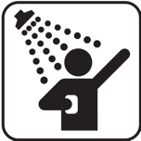
Bathroom and personal hygiene
Water use | Amount (L) | Tally | Total water used
Washing hands or face | 6 L per minute of tap on
Brushing teeth | 6 L per minute of tap on
Shower (low-flow shower head) | 6 L per minute
Shower (standard) | 12 L per minute
Bath (full) | 140 L
Bath (half full) | 80 L
Toilet (half flush) | 3 L per flush
Toilet (full flush) | 6 L per flush
Total bathroom/ personal hygiene use

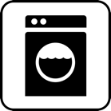
Laundry
Water use | Amount (L) | Tally | Total water used
Washing machine (top loader) | 150 L per wash
Washing machine (front loader) | 80 L per wash
Running tap | 6 L per minute
Total laundry use

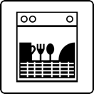
Kitchen

Water use | Amount (L) | Tally | Total water used
Dishwasher (new) | 12 L
Dishwasher (old) | 40 L
Dishes by hand (in sink)

Washing vegetables etc., running tap | 6 L per minute
Total kitchen use

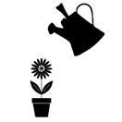
Outdoor use
Water use | Amount (L) | Tally | Total water used
Watering garden or using hose | 30 L per minute
Sprinkler | 17 L per minute
Watering can | 5–10 L per watering can
Leaks | Estimate the amount of water leaking per day
Other

Total outdoor use

Category | Amount total (L)
Drinking | 2
Bathroom and personal hygiene
Kitchen
Laundry
Outdoor
Total water use in one day

