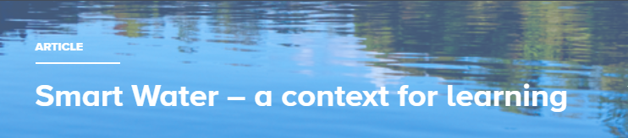

In Aotearoa New Zealand, water is our most precious resource, yet it is often taken for granted and perceived to be unlimited.

Smart Water is a partnership between Hamilton City Council, Waipā District Council and Waitomo District Council. It aims to foster a greater understanding and appreciation of water from source to tap. Smart Water supports schools, organisations and the community to use water sustainably.

The resources use an inquiry approach to connect with water in the Waikato region. However, the science and mātauranga concepts that underpin Smart Water are transferable to other locations across the motu.

The interactive shown below guides you through the Smart Water inquiry cycle and has links to resources.

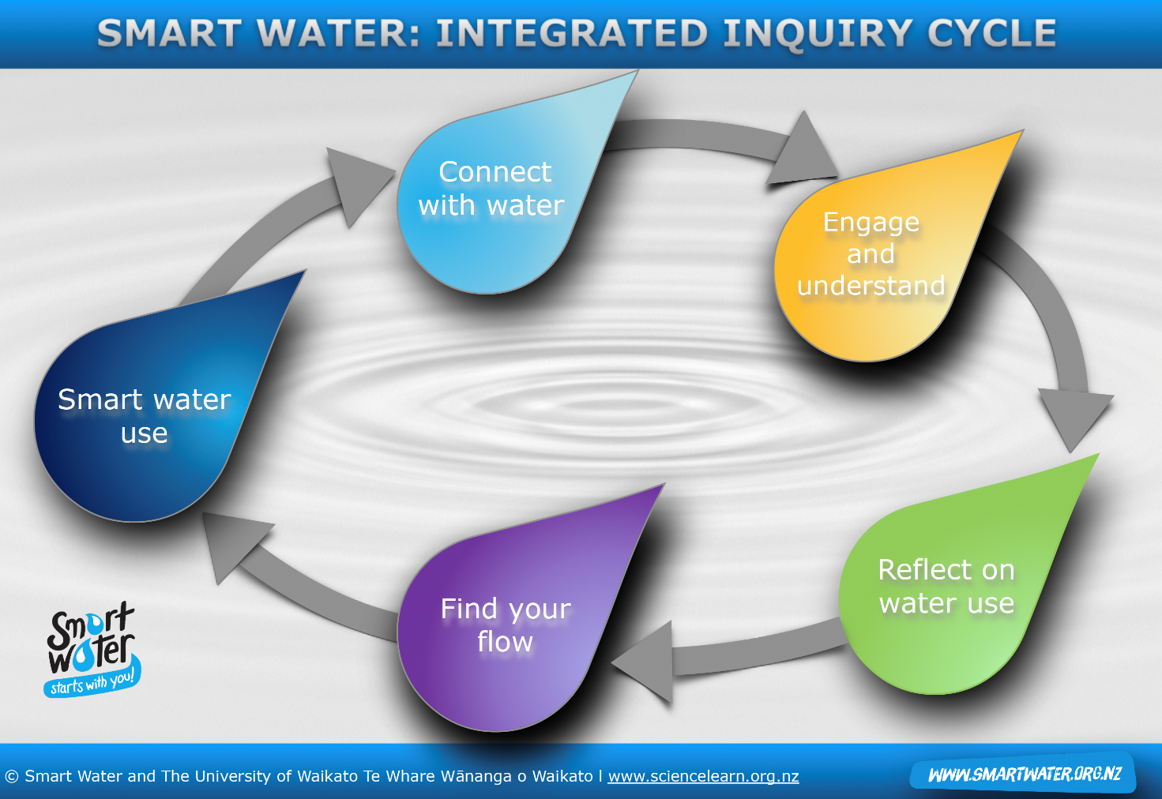

Curriculum links
Smart Water resources are designed for use with years 5–8 – levels 3–4 of the New Zealand Curriculum. They can be adapted for use at other levels and provide opportunities for integrating curriculum subjects such as science, technology, English, social sciences, health and maths.

The resources are underpinned by the key aims and dimensions of environmental education – education in, about and for the environment and kaitiakitanga through participation and action.

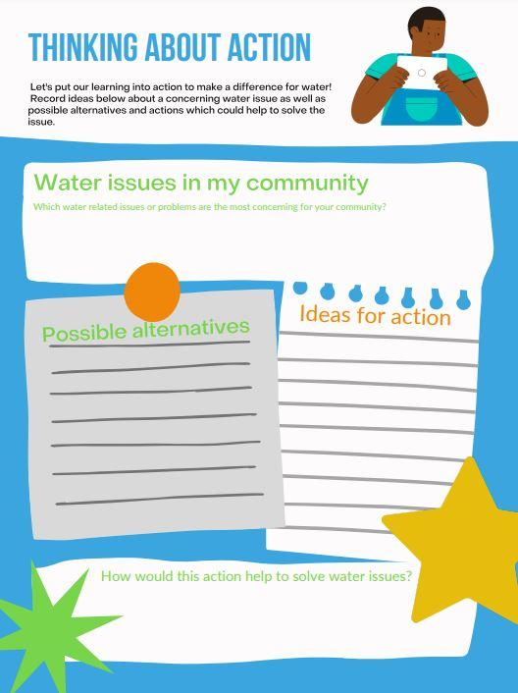

Key concepts
- The suite of resources explore:
- why clean fresh water is important
- water conservation and reasons to save water
- water treatment processes
- te mana o te wai and mauri
- climate change and impacts on freshwater such as the Waikato River
- how we can all look after our water.

Structure of resources
The resources are organised in an inquiry format, with materials to develop each stage of the inquiry. The suite of activities includes learning experiences, videos, slideshows and interactives to encourage deep understanding and engaging experiences. The activities work together to build a solid understanding of water as a natural resource and culminate with students planning a meaningful task to address a local water issue of interest to them. However, each activity also functions as a stand-alone resource so teachers can create a bespoke programme to meet student needs.

Resources to support learning
- Getting to know water – activity
- Water in nature – activity
- Te mana o te wai – activity
- Water in the Waikato – activity
- Global water perspectives – activity
- Getting water ready to drink – activity
- Water use challenge – activity
- Water issues and effects – activity
- Being smart with water – activity
- Smart Water – integrated inquiry cycle – interactive image map

- Water views and values: true or false? – graphic organiser – interactive
- Steps in the drinking water treatment – interactive
- Smart Water: Water is a taonga – slideshow
- Smart Water: Inquiry plan and student reflection – slideshow
Smart Water resources in downloadable PDF format:
- Smart Water: The water cycle
- Hamilton’s water source and supply
- Waipā’s water sources and supply
- Waitomo’s water sources and supply
- Waikato’s water sources and supply
- Tai’s water story
- Makena’s water story
- May’s water story
- Chandran’s water story
- Thinking about action
- Water saving actions in the bathroom
- Water saving actions in the kitchen
- Water saving actions at school and outdoors

Related content on the Science Learning Hub

Taking action for conservation is a PLD webinar. It uses student inquiry, focusing on how to support students to put what they have learned through an inquiry process into action.

Rivers and Us – a context for learning has pedagogical information, and links to numerous resources that explore water use and water quality.

Tōku awa koiora – introduction curates resources about the Waikato River ecosystems and the iwi, researchers and scientists who are working to restore and protect the health and wellbeing of the Waikato River.

